Nov 22, 2021 Как посмотреть какие thread выполняет процесс. Это для отладки полезно, чтобы понять на чём всё повисло, например. Этот аналог есть по Ctrl+T на FreeBSD, как рассказывал Шевченко Александр, это помогает если при начальной загрузке ОС процессы нормально не стартуют и нужно бы понять что с ними. Тоесть такой дебаг.

https://tinkoff.slack.com/archives/CTRAME9LP/p1637570034002700
Shevchenko Aleksandr 11:33 AM

ps -e -o pid,stat,comm,wchan=WIDE-WCHAN-COLUMN | less
PID STAT COMMAND WIDE-WCHAN-COLUMN
1 Ss systemd ep_poll
2 S kthreadd kthreadd
4 S< kworker/0:0H worker_thread
6 S ksoftirqd/0 smpboot_thread_fn
7 S migration/0 smpboot_thread_fn
8 S rcu_bh rcu_gp_kthread
9 S rcu_sched rcu_gp_kthread
10 S< lru-add-drain rescuer_thread
11 S watchdog/0 smpboot_thread_fn

#
# 20200709
#
[root@ds-postgresql416p ~]# date ; ps -p `pidof systemd`,`pidof rsyslogd` -o pid,ppid,user,nice,tty,%mem,vsz,rss,comm,args
Thu Jul 9 11:05:45 MSK 2020
PID PPID USER NI TT %MEM VSZ RSS COMMAND COMMAND
1 0 root 0 ? 0.2 489696 4316 systemd /usr/lib/systemd/systemd --switched-root --system --deserialize 22
18141 1 root 0 ? 1.6 396712 31920 rsyslogd /usr/sbin/rsyslogd -n
[root@ds-postgresql416p ~]#

#
[root@ds-postgresql416p ~]# watch -n 600 '(date ; ps -p `pidof systemd`,`pidof rsyslogd` -o pid,ppid,user,nice,%mem,vsz,rss,comm,args) | tee -a /var/tmp/$(date +%Y%m%d).ps.rsyslog.systemd.log'
[root@ds-postgresql416p ~]#

# Here is another usefull way to use ps with top utility.
[root@ds-postgresql416p ~]# top -b -n1 -p$(ps -Crsyslogd -opid h)
top - 17:22:09 up 47 days, 23:44, 2 users, load average: 0.22, 0.29, 0.34
Tasks: 1 total, 0 running, 1 sleeping, 0 stopped, 0 zombie
%Cpu(s): 0.0 us, 0.0 sy, 0.0 ni,100.0 id, 0.0 wa, 0.0 hi, 0.0 si, 0.0 st
KiB Mem : 1882400 total, 60792 free, 1431544 used, 390064 buff/cache
KiB Swap: 2097148 total, 1422496 free, 674652 used. 281612 avail Mem

PID USER PR NI VIRT RES SHR S %CPU %MEM TIME+ COMMAND
3415 root 20 0 396744 5016 3656 S 0.0 0.3 0:02.88 rsyslogd
[root@ds-postgresql416p ~]# ps -Crsyslogd -opid h
3415
[root@ds-postgresql416p ~]# ps -Crsyslogd -opid
PID
3415
[root@ds-postgresql416p ~]#
[root@ds-postgresql416p ~]# watch 'top -b -n1 -p$(ps -Crsyslogd -opid h);echo;df -h /var/log'

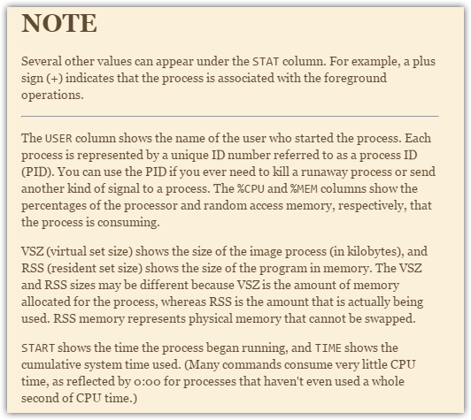
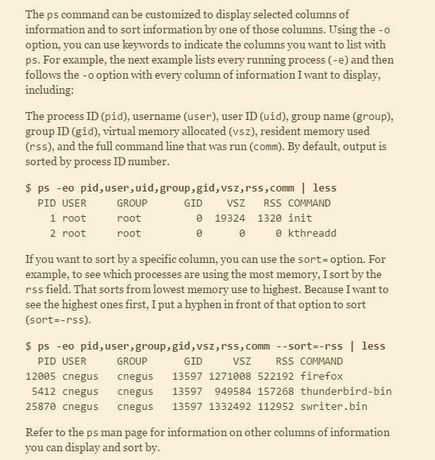

[root@vm-vol-nag4-tst objects]# ps -eo pid,user,vsz,rss,comm --sort=-rss | head
PID USER VSZ RSS COMMAND
23358 nagios 3410772 2829748 telegram-cli
11322 nagios 830108 136772 nagios
30510 root 180992 60216 puppet
8781 root 135964 42472 puppet
19722 netdata 1215936 36784 netdata
19658 root 46772 34124 atop
30081 root 371616 15052 httpd
8550 root 448248 14400 jupyter-noteboo
13580 apache 470332 13972 httpd
[root@vm-vol-nag4-tst objects]#

# Print info about process with PID.
ps -p PID -o ppid,user,nice,tty,comm,args

Сортирует по используемой памяти в обратном порядке
ps auxwS --sort=-vsize
Display the top ten running processes - sorted by memory usage
ps axo %mem,pid,euser,cmd | sort -nr | head -n 10

Полная информация в виде дерева с широкой командной строкой и информацией о хозяине процесса.
ps -auxefw

Создаёт полный листинг в виде дерева.
ps axjf
# How it looks like.
[root@ds-prod-tbru-ts-as-2 ~]# ps faux | grep sshd
root 1597 0.0 0.0 112808 4316 ? Ss May30 0:00 /usr/sbin/sshd -D
root 15780 0.0 0.0 156676 5548 ? Ss 17:40 0:00 \_ sshd: bsv [priv]
bsv 15782 0.0 0.0 156992 2680 ? S 17:40 0:00 \_ sshd: bsv@pts/0
root 17507 0.0 0.0 112704 980 pts/0 S+ 18:06 0:00 \_ grep --color=a
uto sshd

Листинг с полной строкой запуска
ps ax -c

Прикольно так же сделать такой канал
ps ax -c | less

Показ nice процессов (если значение -20 это значит процесс имеет максимально высокий
приоритет; если значение 19 это значит процесс имеет самый низкий приоритет и
практически не выполняется)
ps ax -o ppid,user,nice,tty,comm,args
-contactquietly -terse \

Чтобы посмотреть всю строку запуска команды (которая не влазит в терминал)
ps aux | less -S

[support@centos00 nrpe.d]$ pidof ssh | xargs ps -p
PID TTY STAT TIME COMMAND
1045 pts/4 S+ 0:01 ssh bsv@nag2
2973 pts/5 S+ 0:01 ssh bsv@monitoring2
27011 pts/8 S+ 0:00 ssh root@10.217.18.219
29471 pts/7 S+ 0:00 ssh root@10.217.18.218
[support@centos00 nrpe.d]$

Show ssh process without process with grep.
cld ~ # ps aux | grep 'ss[h]'
root 3803 0.0 0.0 25624 1124 ? Ss 19:50 0:00 /usr/sbin/sshd
cld ~ #

# Show info about two process with pid 3712 and 36614.
[root@ds-db-tst ~]# ps -p 3712 -p 36614 -uefw
Warning: bad syntax, perhaps a bogus '-'? See /usr/share/doc/procps-3.2.8/FAQ
USER PID %CPU %MEM VSZ RSS TTY STAT START TIME COMMAND
oracle 36614 0.3 0.0 363188 29748 ? Ss 13:33 0:15 ora_dbw0_BUFF_DEV HOSTNAME=ds-db-tst SHELL=/bin/bash TERM=xterm HISTSIZE=1000 NLS_LANG=AMERICAN_AMERICA.CL8MSWIN1251 QTDIR=/usr/lib64/q
oracle 3712 0.0 0.0 264572 37108 ? Ss Sep21 0:02 ora_gen0_XXI_TST HOSTNAME=ds-db-tst SHELL=/bin/bash TERM=xterm HISTSIZE=1000 NLS_LANG=AMERICAN_AMERICA.CL8MSWIN1251 QTDIR=/usr/lib64/qt
[root@ds-db-tst ~]#

# List of Zombie process.

root@m1-np01t:~# ps -faux | grep -e "^USER" -e " [Z]" | head -n 2
USER PID %CPU %MEM VSZ RSS TTY STAT START TIME COMMAND
d.chern+ 55353 0.0 0.0 0 0 ? Z Sep11 0:02 | \_ [python3] <defunct>
root@m1-np01t:~# ps -faux | grep -e "^USER" -e " [Z]" | wc -l
31
root@m1-np01t:~#

[root@vm-autotest01t ~]# ps auxfw | grep -e "^USER" -e " [Z]"
USER PID %CPU %MEM VSZ RSS TTY STAT START TIME COMMAND
jenkins 12183 0.0 0.0 0 0 ? Z 18:35 0:00 | \_ [sh] <defunct>
jenkins 12203 0.0 0.0 0 0 ? Z 18:35 0:00 | \_ [sh] <defunct>
jenkins 12205 0.0 0.0 0 0 ? Z 18:35 0:00 | \_ [sh] <defunct>
jenkins 12210 0.0 0.0 0 0 ? Z 18:35 0:00 | \_ [sh] <defunct>
jenkins 12236 0.0 0.0 0 0 ? Z 18:35 0:00 | \_ [sh] <defunct>
jenkins 12243 0.0 0.0 0 0 ? Z 18:35 0:00 | \_ [sh] <defunct>
jenkins 12253 0.0 0.0 0 0 ? Z 18:35 0:00 | \_ [sh] <defunct>
jenkins 12269 0.0 0.0 0 0 ? Z 18:35 0:00 | \_ [sh] <defunct>
jenkins 12299 0.0 0.0 0 0 ? Z 18:35 0:00 | \_ [sh] <defunct>
jenkins 12307 0.0 0.0 0 0 ? Z 18:35 0:00 | \_ [sh] <defunct>
jenkins 12328 0.0 0.0 0 0 ? Z 18:35 0:00 | \_ [sh] <defunct>
jenkins 12337 0.0 0.0 0 0 ? Z 18:35 0:00 | \_ [sh] <defunct>
jenkins 12351 0.0 0.0 0 0 ? Z 18:35 0:00 | \_ [sh] <defunct>
jenkins 12365 0.0 0.0 0 0 ? Z 18:35 0:00 | \_ [sh] <defunct>
jenkins 12396 0.0 0.0 0 0 ? Z 18:35 0:00 | \_ [sh] <defunct>
jenkins 12630 0.0 0.0 0 0 ? Z 18:35 0:00 | \_ [sh] <defunct>
jenkins 12798 0.0 0.0 0 0 ? Z 18:35 0:00 | \_ [sh] <defunct>
jenkins 12801 0.0 0.0 0 0 ? Z 18:35 0:00 | \_ [sh] <defunct>
jenkins 12844 0.0 0.0 0 0 ? Z 18:35 0:00 | \_ [sh] <defunct>
jenkins 12854 0.0 0.0 0 0 ? Z 18:35 0:00 | \_ [sh] <defunct>
[root@vm-autotest01t ~]#

https://askubuntu.com/questions/111422/how-to-find-zombie-process

root@m1-np01t:~# /usr/lib/nagios/plugins/check_procs -w 5 -c 10 -s Z
PROCS CRITICAL: 30 processes with STATE = Z | procs=30;5;10;0;
root@m1-np01t:~# ps aux | grep 'Z'
USER PID %CPU %MEM VSZ RSS TTY STAT START TIME COMMAND
root 7654 0.0 0.0 0 0 ? Z 17:46 0:04 [python3] <defunct>
root 7655 0.0 0.0 0 0 ? Z 17:46 0:04 [python3] <defunct>
root 7656 0.0 0.0 0 0 ? Z 17:46 0:04 [python3] <defunct>
root 7657 0.0 0.0 0 0 ? Z 17:46 0:04 [python3] <defunct>
root 7658 0.0 0.0 0 0 ? Z 17:46 0:04 [python3] <defunct>
root 7659 0.0 0.0 0 0 ? Z 17:46 0:04 [python3] <defunct>
root 7660 0.0 0.0 0 0 ? Z 17:46 0:04 [python3] <defunct>
root 7661 0.0 0.0 0 0 ? Z 17:46 0:04 [python3] <defunct>
root 7662 0.0 0.0 0 0 ? Z 17:46 0:04 [python3] <defunct>
root 7663 0.0 0.0 0 0 ? Z 17:46 0:04 [python3] <defunct>
root 7664 0.0 0.0 0 0 ? Z 17:46 0:04 [python3] <defunct>
root 7665 0.0 0.0 0 0 ? Z 17:46 0:04 [python3] <defunct>
root 7666 0.0 0.0 0 0 ? Z 17:46 0:04 [python3] <defunct>
root 7667 0.0 0.0 0 0 ? Z 17:46 0:04 [python3] <defunct>
root 7668 0.0 0.0 0 0 ? Z 17:46 0:04 [python3] <defunct>
root 7669 0.0 0.0 0 0 ? Z 17:46 0:04 [python3] <defunct>
root 7670 0.0 0.0 0 0 ? Z 17:46 0:04 [python3] <defunct>
root 7671 0.0 0.0 0 0 ? Z 17:46 0:04 [python3] <defunct>
root 7672 0.0 0.0 0 0 ? Z 17:46 0:04 [python3] <defunct>
root 7673 0.0 0.0 0 0 ? Z 17:46 0:04 [python3] <defunct>
root 7674 0.0 0.0 0 0 ? Z 17:46 0:04 [python3] <defunct>
root 7675 0.0 0.0 0 0 ? Z 17:46 0:04 [python3] <defunct>
root 7676 0.0 0.0 0 0 ? Z 17:46 0:04 [python3] <defunct>
root 7677 0.0 0.0 0 0 ? Z 17:46 0:04 [python3] <defunct>
root 7678 0.0 0.0 0 0 ? Z 17:46 0:04 [python3] <defunct>
root 7679 0.0 0.0 0 0 ? Z 17:47 0:04 [python3] <defunct>
root 7680 0.0 0.0 0 0 ? Z 17:47 0:04 [python3] <defunct>
root 7681 0.0 0.0 0 0 ? Z 17:47 0:04 [python3] <defunct>
root 7685 0.0 0.0 0 0 ? Z 17:47 0:04 [python3] <defunct>
root 7686 0.0 0.0 0 0 ? Z 17:47 0:04 [python3] <defunct>
root 9090 0.0 0.0 14224 1012 pts/3 S+ 19:21 0:00 grep --color=auto Z
root@m1-np01t:~#

root@m1-np01t:~# pstree -achplu | less
…
|-screen,22940,d.chernyavskiy
| `-bash,22941
| `-sudo,22962,root jupyter-notebook --ip 0.0.0.0 --allow-root
| `-jupyter-noteboo,22963 /usr/local/bin/jupyter-notebook --ip 0.0.0.0 --allow-root
| |-python3,6129 -m ipykernel_launcher -f /home/d.chernyavskiy/.local/share/jupyter/runtime/kernel-ef00e583-e8ce-47b2-a7e9-6c8f76fd2e6c.json
| | |-{python3},6134
| | |-{python3},6135
| | |-{python3},6136
| | |-{python3},6137
...

#
# 20181214
#

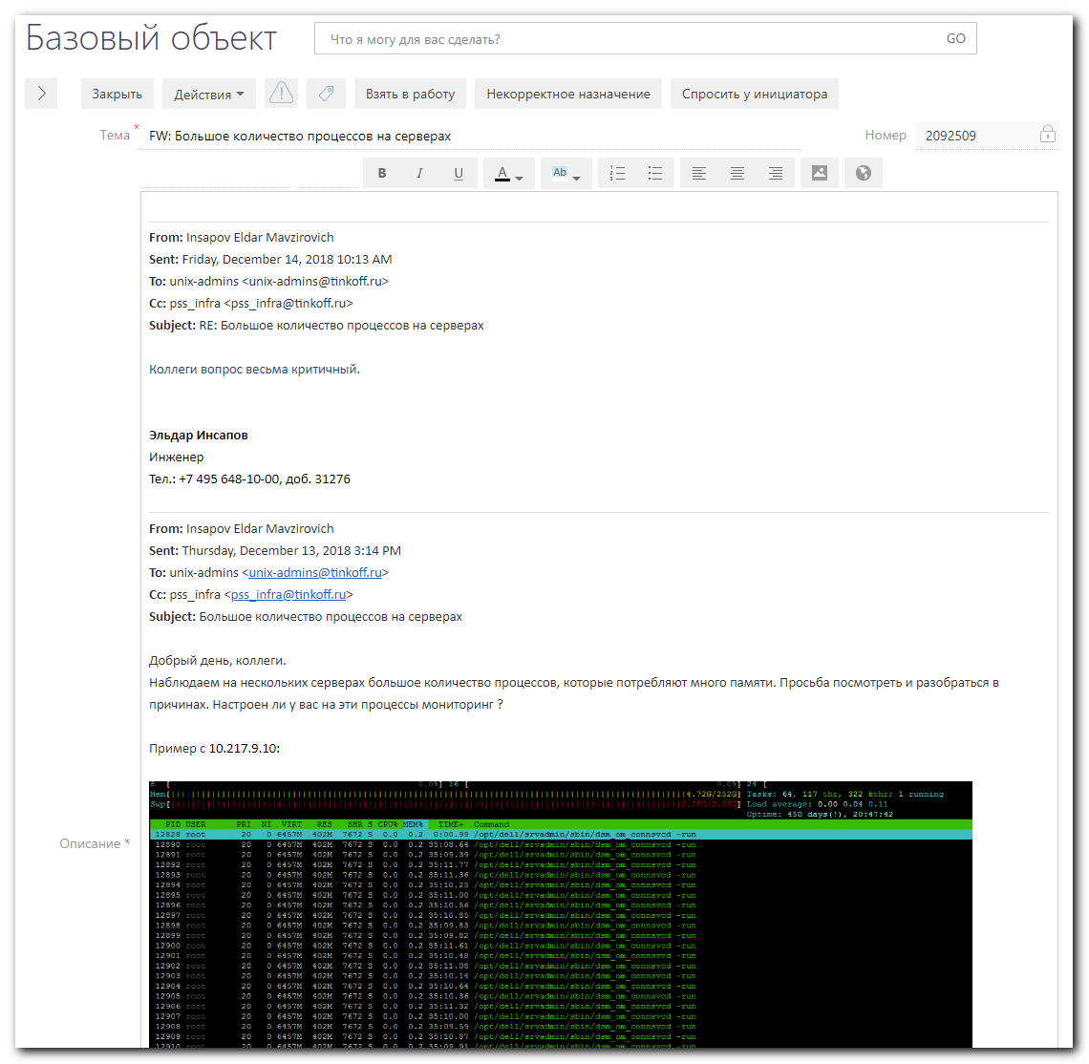
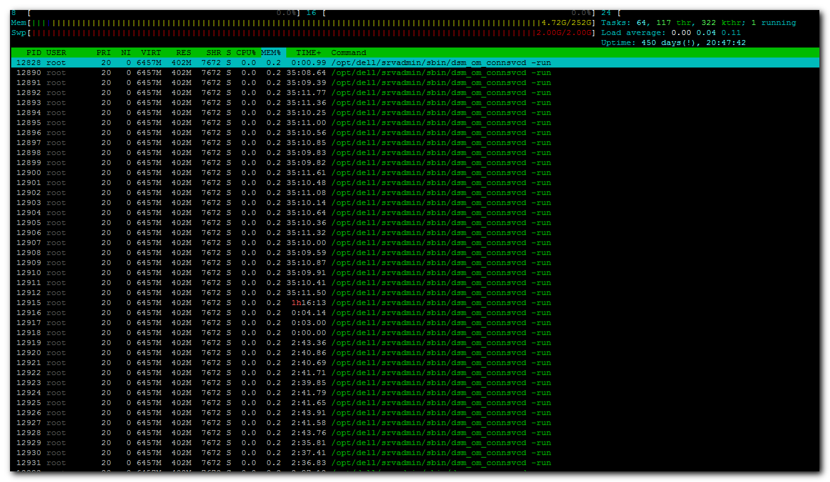

From: Belogrud Sergey Vladimirovich
Sent: Friday, December 14, 2018 12:15 PM
To: Insapov Eldar Mavzirovich <e.insapov@tinkoff.ru>
Cc: pss_infra <pss_infra@tinkoff.ru>; unix-admins <unix-admins@tinkoff.ru>
Subject: RE: Большое количество процессов на серверах

Добрый день.

Сделайте пожалуйста задачу в SD, что и всегда рекомендутся делать.

Не необходимый сервис (процесс) на сервере ds-pr-onltraces01p был отключен.

Состояние потребления памяти процессами до отключения опционального сервиса dsm_om_connsvc.
PID USER VSZ RSS COMMAND
12826 root 6612156 412684 dsm_om_connsvcd
137370 root 791464 24200 dsm_sa_datamgrd
137448 root 725796 19144 dsm_sa_datamgrd
137439 root 511356 5764 dsm_sa_snmpd
137412 root 300940 3672 dsm_sa_eventmgr
12839 root 632376 1036 dsm_om_shrsvcd
12825 root 137896 472 dsm_om_connsvcd

Отключение сервиса dsm_om_connsvc. Это можно сделать на всех серверах, где для вас это критично.
[root@ds-pr-onltraces01p ~]# systemctl stop dsm_om_connsvc
[root@ds-pr-onltraces01p ~]# systemctl disable dsm_om_connsvc

Состояние потребления памяти процессами после отключения опционального сервиса dsm_om_connsvc.
PID USER VSZ RSS COMMAND
138900 root 791332 22824 dsm_sa_datamgrd
140194 root 725664 17832 dsm_sa_datamgrd
140187 root 511356 5748 dsm_sa_snmpd
140160 root 300940 3668 dsm_sa_eventmgr
12839 root 632376 1036 dsm_om_shrsvcd

Вкраце, что есть VSZ, RSS.
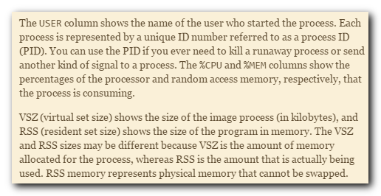
Описание процессов.
https://www.dell.com/support/manuals/us/en/04/dell-openmanage-server-administrator-v8.3/omsa_ug/server-administrator-services?guid=guid-ccdabde1-2904-4aa9-8c9a-9fbcde5df616&lang=en-us


Сергей Белогруд
Старший системный администратор
Тел.: +7 495 648-10-00, доб. 2173

From: Insapov Eldar Mavzirovich
Sent: Friday, December 14, 2018 10:13 AM
To: unix-admins <unix-admins@tinkoff.ru>
Cc: pss_infra <pss_infra@tinkoff.ru>
Subject: RE: Большое количество процессов на серверах

Коллеги вопрос весьма критичный.

Эльдар Инсапов
Инженер
Тел.: +7 495 648-10-00, доб. 31276

From: Insapov Eldar Mavzirovich
Sent: Thursday, December 13, 2018 3:14 PM
To: unix-admins <unix-admins@tinkoff.ru>
Cc: pss_infra <pss_infra@tinkoff.ru>
Subject: Большое количество процессов на серверах

Добрый день, коллеги.
Наблюдаем на нескольких серверах большое количество процессов, которые потребляют много памяти. Просьба посмотреть и разобраться в причинах. Настроен ли у вас на эти процессы мониторинг ?

Пример с 10.217.9.10:

Эльдар Инсапов
Инженер
Тел.: +7 495 648-10-00, доб. 31276

#
# Related articles.
#
https://marc.info/?l=linux-poweredge&m=134117343231516
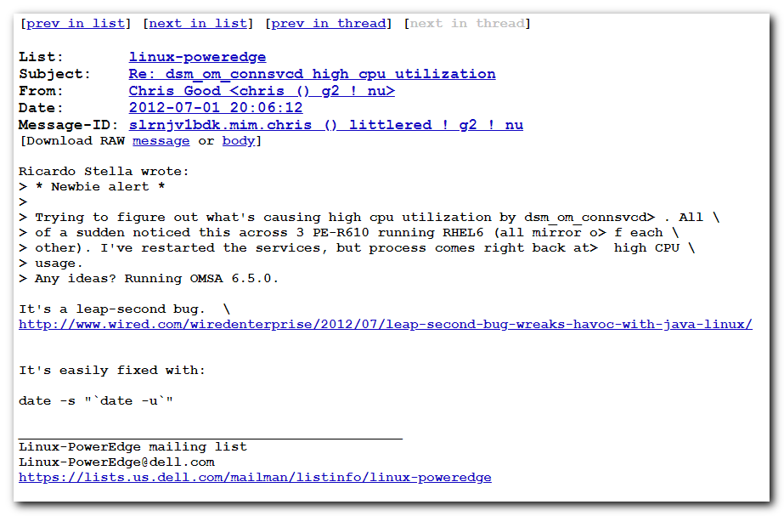

https://serverfault.com/questions/641855/dell-openmanage-web-interface-inaccessible
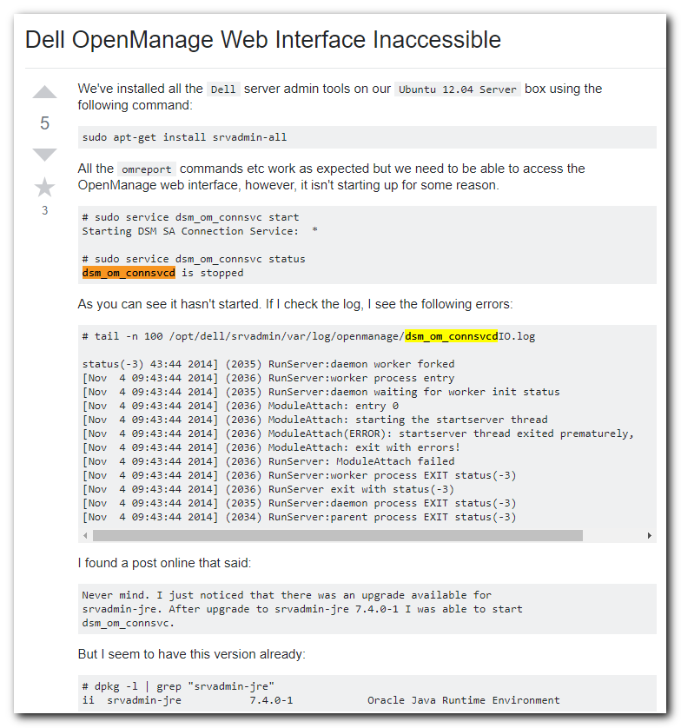

https://www.dell.com/support/manuals/us/en/04/dell-openmanage-server-administrator-v8.3/omsa_ug/server-administrator-services?guid=guid-ccdabde1-2904-4aa9-8c9a-9fbcde5df616&lang=en-us
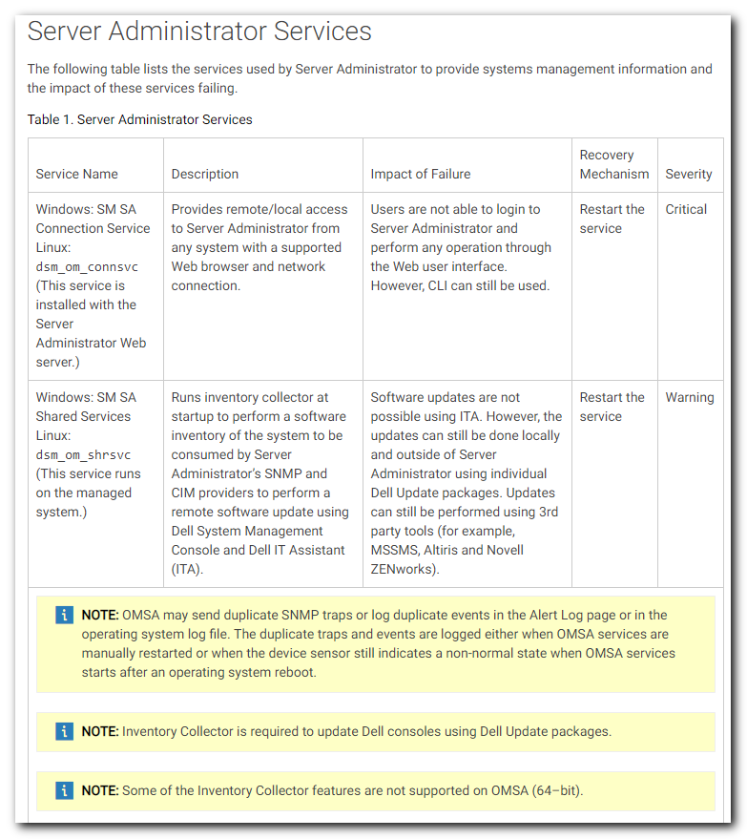
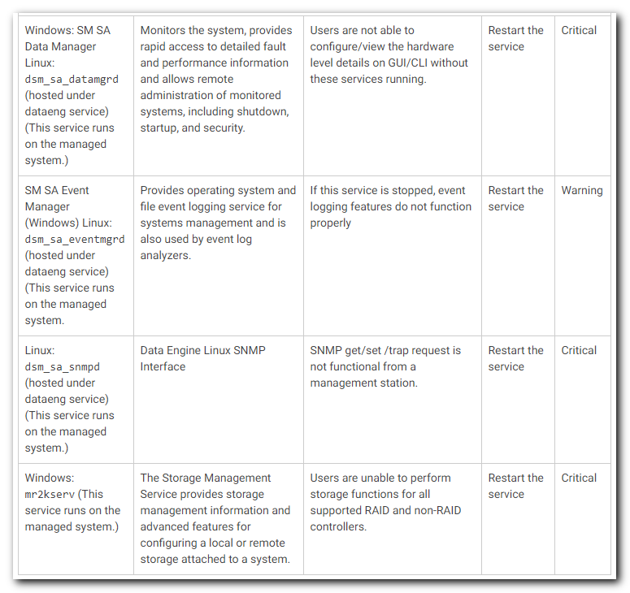

Dell OpenManage Server Administrator Version 8.3 User's Guide

Server Administrator Services
The following table lists the services used by Server Administrator to provide systems management information and the impact of these services failing.
Service Name | Description | Impact of Failure | Recovery Mechanism | Severity
Windows: SM SA Connection Service Linux:dsm_om_connsvc(This service is installed with the Server Administrator Web server.) | Provides remote/local access to Server Administrator from any system with a supported Web browser and network connection. | Users are not able to login to Server Administrator and perform any operation through the Web user interface. However, CLI can still be used. | Restart the service | Critical
Windows: SM SA Shared Services Linux:dsm_om_shrsvc(This service runs on the managed system.) | Runs inventory collector at startup to perform a software inventory of the system to be consumed by Server Administrator’s SNMP and CIM providers to perform a remote software update using Dell System Management Console and Dell IT Assistant (ITA). | Software updates are not possible using ITA. However, the updates can still be done locally and outside of Server Administrator using individual Dell Update packages. Updates can still be performed using 3rd party tools (for example, MSSMS, Altiris and Novell ZENworks). | Restart the service | Warning
- NOTE: OMSA may send duplicate SNMP traps or log duplicate events in the Alert Log page or in the operating system log file. The duplicate traps and events are logged either when OMSA services are manually restarted or when the device sensor still indicates a non-normal state when OMSA services starts after an operating system reboot.
- NOTE: Inventory Collector is required to update Dell consoles using Dell Update packages.
- NOTE: Some of the Inventory Collector features are not supported on OMSA (64–bit).
Windows: SM SA Data Manager Linux:dsm_sa_datamgrd(hosted under dataeng service) (This service runs on the managed system.) | Monitors the system, provides rapid access to detailed fault and performance information and allows remote administration of monitored systems, including shutdown, startup, and security. | Users are not able to configure/view the hardware level details on GUI/CLI without these services running. | Restart the service | Critical
SM SA Event Manager (Windows) Linux:dsm_sa_eventmgrd(hosted under dataeng service) (This service runs on the managed system. | Provides operating system and file event logging service for systems management and is also used by event log analyzers. | If this service is stopped, event logging features do not function properly | Restart the service | Warning
Linux:dsm_sa_snmpd(hosted under dataeng service) (This service runs on the managed system.) | Data Engine Linux SNMP Interface | SNMP get/set /trap request is not functional from a management station. | Restart the service | Critical
Windows:mr2kserv (This service runs on the managed system.) | The Storage Management Service provides storage management information and advanced features for configuring a local or remote storage attached to a system. | Users are unable to perform storage functions for all supported RAID and non-RAID controllers. | Restart the service | Critical

#
# 20200311
#
# https://www.cyberciti.biz/faq/linux-list-processes-by-user-names-euid-and-ruid/
#

How to see process created by a specific user in Linux
See all process crated by user named tom:
ps -u tom

OR
ps -U tom

EUID is the Effective User ID. The effective user ID describes the user whose file access permissions are used by the process. RUID is the Real User ID. The real user ID identifies the user who created the process. So:
- -u tom : Show all processes by RUID
- -U tom : Display all processes by EUID
You can get a list of every process running as vivek (real [RUID] & effective ID [EUID]) in user format:
ps -U vivek -u vivek
ps -U vivek -u vivek u
## see all process run by, qemu and postfix users ##
ps -U qemu -u qemu
ps -U postfix -u postfix
ps -U postfix -u postfix u

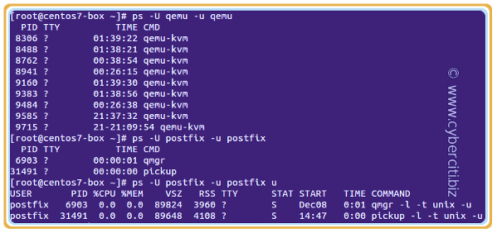

How to show all processes for a specific user using top/htop
The syntax is pretty simple to see all processes created by a user named vivek:
top -U vivek

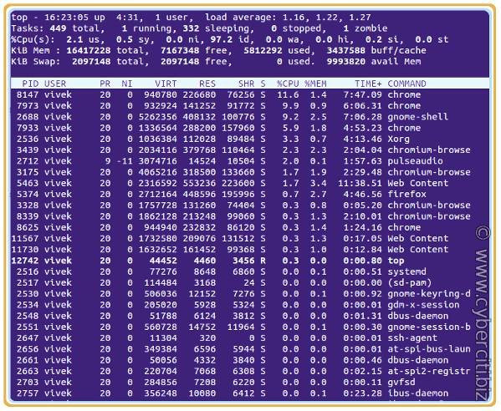Linux list processes by user name using top command
My favorite command to check what user is running a process:
htop -u vivek

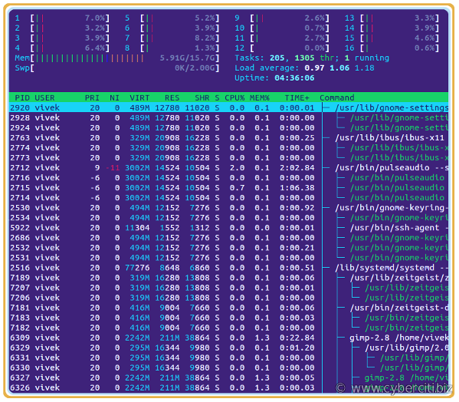Linux show all processes created and used by a user named ‘vivek’ using htop

How to display user ID associated with a process
Another option is to use the combination of ps command and grep command/egrep command:
sudo ps -ef | grep {userName}
sudo ps -efl | grep {userName}
sudo ps -efl | grep vivek
sudo ps -ef | grep nginx
sudo ps -efl | grep 'www-data'

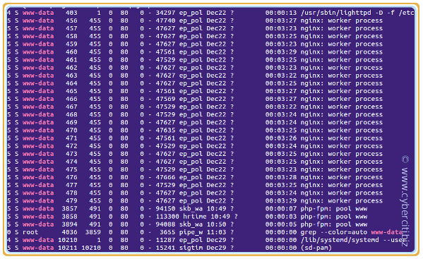The www-data user ID associated with a Linux process named lighttpd, nginx, and php-fpm.
To confirm user IDs run the cat command/egrep command/grep command or /etc/passwd as follows:
cat /etc/passwd
grep 'www-data' /etc/passwd

You can print process tree of user named www-data too, run the pstree command:
pstree [options] {userName}
pstree www-data
pstree -l -a -p -s vivek
pstree -laps www-dat

Where,
- -l : Long format
- -a : Show command line args
- -p : Display Linux PIDs
- -s : See parents of the selected process

The pgrep command
The pgrep command can look up processes based on usernames. The syntax is:
### Only match processes whose Linux effective user ID (euid) is listed ###
pgrep -u euid
### Only match processes whose effective user ID (uid) is listed ##
pgrep -U uid
pgrep -l -u vivek
pgrep -l -U www-data

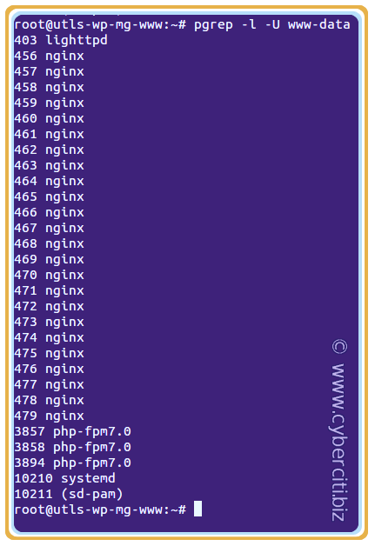

Conclusion

